Home Exercise
Elevators
Base
Plan an elevator system according to the following requirements:
1. The building has 10 floors (including ground floor) and 5 elevators.
2. Near each floor, present a green button to call an elevator
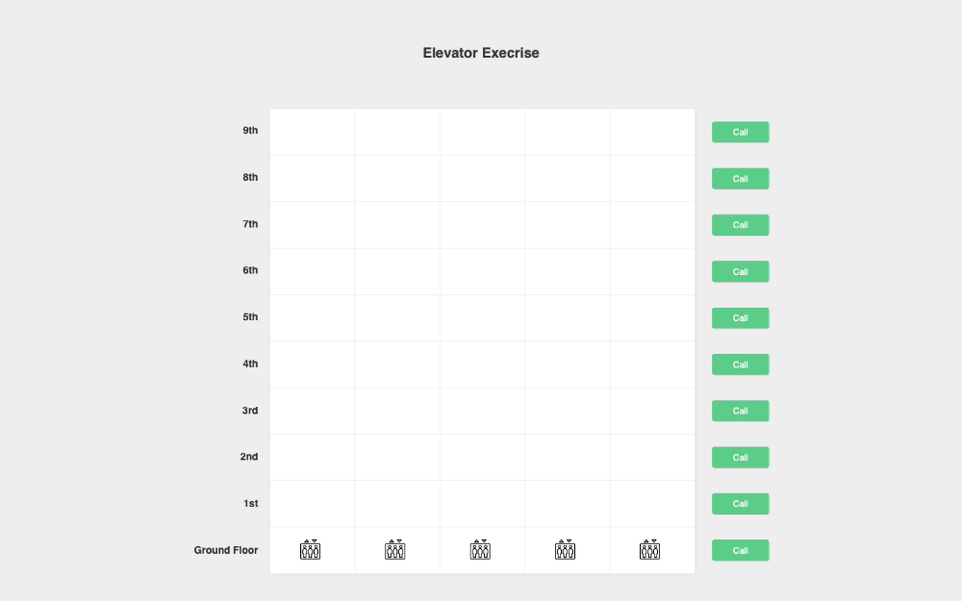
Calling an elevator
3. Change the “call” button to red, and change the text to “waiting”
4. Identify the closet elevator to the floor, and send the elevator to that floor
a. There's a chance all the elevators will be occupied at that moment
b. Do not miss any calls (queue?)
5. The elevator should move toward the select floor in a smooth movement
6. Measure the time it took the elevator to reach the designated floor
7. Change the elevator color to red
Elevator reached the floor
8. Make a sound when the elevator reaches the floor
9. Change the elevator color to green
10.Wait 2 seconds before moving to the next call (If exists)
11. Change the button text to “arrived” and the design according to the design below
12. After the 2 seconds, change the elevator color back to black, and change the
button to “call”, with the initial design

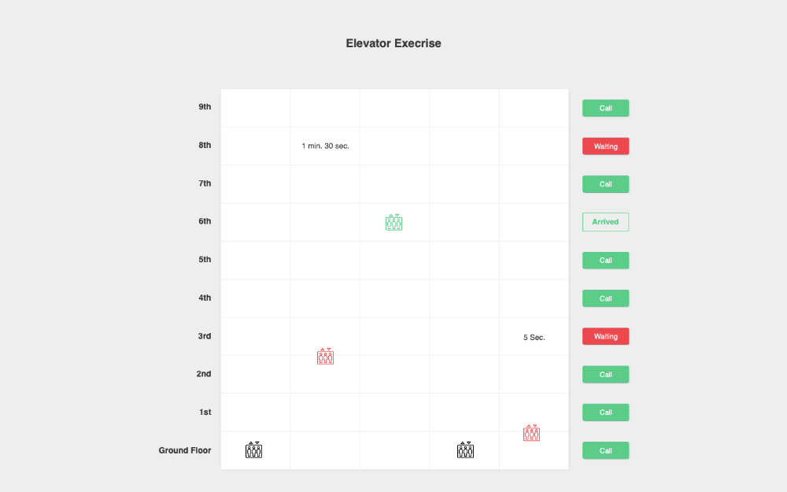
Technical
13. Create a clear design infrastructure (CSS/SCSS))
14. Create an entry point to the application, for your choosing
15. Try to follow the design as much as possible
16. Elevator SVG file can be found here
Bonus
17. Present the time it took the elevator to reach the floor (As presented in the design)
18. Allow defining a custom number of floors in advance
19. Allow defining a custom number of elevators in advance
Conclusion
● The purpose of the exrc is to test the infrastructure and the design of your code, but
we the solution should also work as expected
● Please use one of the following frameworks
○ Angular
○ React
○ Vue
○ Vanilla (Native JS)
● No need to build the HTML in JS (example elem.createElement(‘div’))
● Send the solution through GitHub or Google Drive (Make sure to give view
permission)

Good Luck

